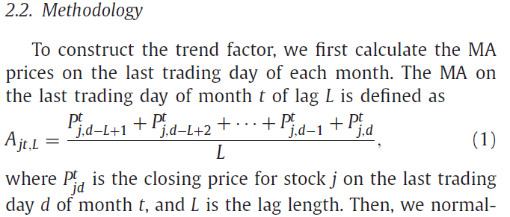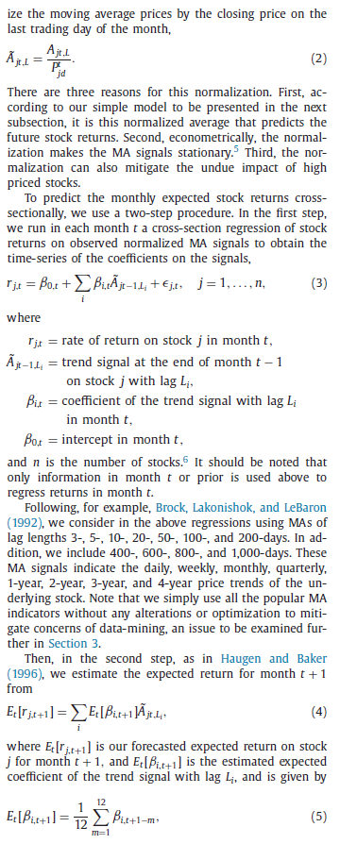

import pandas as pd

import numpy as np

#rtn_monthly = pd.read_excel('A_trend_factor.xlsm',sheetname='월별수익률1')

#rtn_monthly_notgross = pd.read_excel('A_trend_factor.xlsm',sheetname='월별수익률2')

#rtn_monthly_notgross.to_pickle('rtn_monthly_notgross')

#monthly_date = pd.read_excel('A_trend_factor.xlsm',sheetname='월말날짜1',header=None)

#rtn_daily1.to_pickle('rtn_daily1')

#rtn_monthly.to_pickle('rtn_monthly')

rtn_monthly_notgross = pd.read_pickle('rtn_monthly_notgross') #수익률을 gross로 하지 말아야 하나?

monthly_date = pd.read_pickle('monthly_date')

rtn_monthly = pd.read_pickle('rtn_monthly') # gross 수익률

rtn_daily = pd.read_pickle('rtn_daily')

higher_return_final = pd.DataFrame(np.zeros((1,134)))

lower_return_final = pd.DataFrame(np.zeros((1,134)))

rtn_monthly = rtn_monthly_notgross

for n in range(12,146):

beta_3_temp = pd.DataFrame(np.zeros((1,12)))

for i in range(0,12):

#df.columns.get_loc() 이걸 하면 column 위치를 알 수 있다!!

rebalancing_date_column=rtn_daily.columns.get_loc(monthly_date.iloc[0,n-i])

#3일 moving_average를 마지막 가격으로 나누워준 값

# iloc을 이용해서 column 범위를 구하면 원하는 column +1을 해줘야하네

ma_3=pd.DataFrame(np.sum(rtn_daily.iloc[:,rebalancing_date_column-2:rebalancing_date_column+1],axis=1)/3/rtn_daily.iloc[:,rebalancing_date_column])

ma_3=ma_3[ma_3[0].notnull()]

future_rtn = pd.DataFrame(rtn_monthly.iloc[:,n-i+1])

# future_rtn = pd.DataFrame(rtn_daily.loc[:,monthly_date.iloc[0,n+1-i]])

future_rtn = future_rtn[future_rtn[monthly_date.iloc[0,n+1-i]].notnull()]

ma_3_temp = pd.concat([ma_3,future_rtn],axis=1)

ma_3_temp = ma_3_temp.assign(product=ma_3_temp.iloc[:,0]*ma_3_temp.iloc[:,1])

ma_3_temp = ma_3_temp[ma_3_temp['product'].notnull()]

beta_3 = pd.DataFrame(np.dot(np.linalg.inv(np.dot(ma_3.T,ma_3)),np.dot(ma_3_temp[0].T,ma_3_temp.iloc[:,1])))

beta_3_temp.iloc[0,i]=beta_3.iloc[0,0]

beta_3=np.average(beta_3_temp)

#다음기 ma랑 곱해

ma_3=pd.DataFrame(np.sum(rtn_daily.iloc[:,rebalancing_date_column-1:rebalancing_date_column+2],axis=1)/3/rtn_daily.iloc[:,rebalancing_date_column+1])

ma_3=ma_3[ma_3[0].notnull()]

return_3=beta_3 * ma_3

이런식으로 3 5 10 20 50 100 200 400 600 800 1000 각각 구해서 final_return=return_3+return_5+return_10+return_20+return_50+return_100+return_200+return_400+return_600+return_800+return_1000

final_return= pd.concat([final_return,pd.DataFrame(rtn_monthly.iloc[:,n+1])],axis=1, join_axes=[final_return.index])

final_return = final_return[final_return.iloc[:,1].notnull()]

final_return = final_return.assign(rnk=final_return.iloc[:,0].rank(method='first',ascending=False))

rtn_min=np.percentile(final_return['rnk'],20)

rtn_max=np.percentile(final_return['rnk'],80)

higher_return = final_return[final_return['rnk']<rtn_min]

lower_return = final_return[final_return['rnk']>rtn_max]

higher_return_final[n-12] = np.average(higher_return.iloc[:,1])

lower_return_final[n-12] = np.average(lower_return.iloc[:,1])